- \Operation\Basic settings\General setting
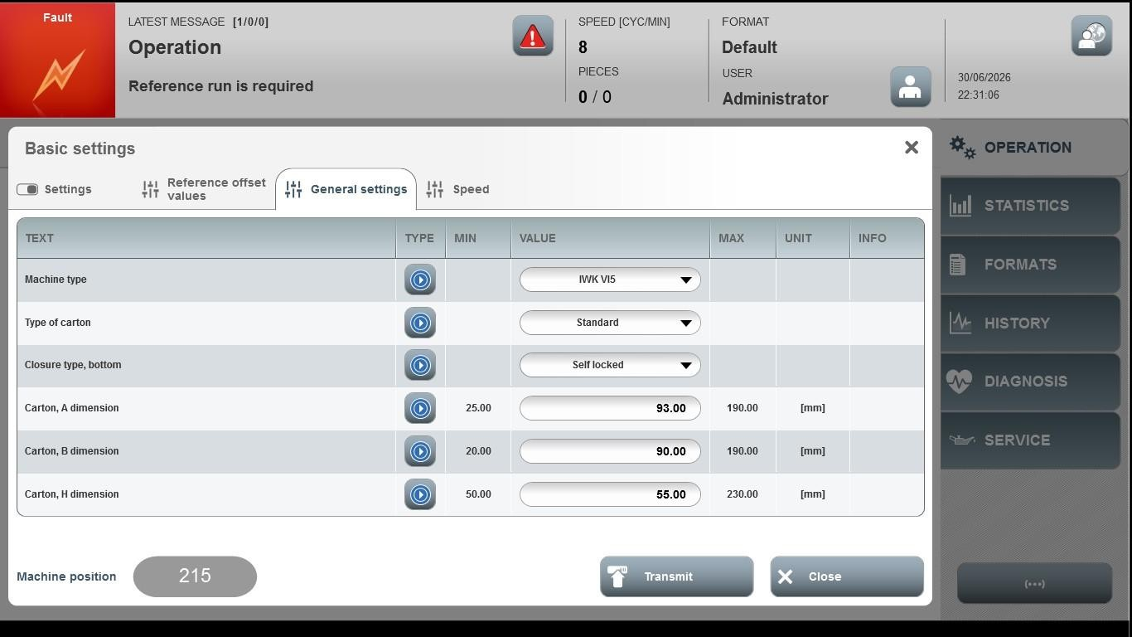
Acceptance criterion | Limits | Pass / Fail: Dev-No. | Date | Initials
Screen matches screenshot | N / A
Carton, A dimension | 25.00…190.0
Carton, B dimension | 20.00…190.0
Carton, C dimension | 50.00…230.0

